note that while these a 4 cases are the only clearly and substance incorrect of the 22 tested signs there was a trend throughout all signs where while the area/location was correct the stroke frames was arguably too short so that the section was more of a snippet of a given sign. this could probably be help by adjusting parameters so that the dominant hand isn't actively touching the other hand at the start and end frame of the phase.
Error 1: 3c4d3247-6258-4816-9edf-a0f0e66b20b7
Preparation frames: 54 (frames 0-53)
Stroke frames: 16 (frames 54-69)
Retraction frames: 1 (frames 69-69)
graphs: 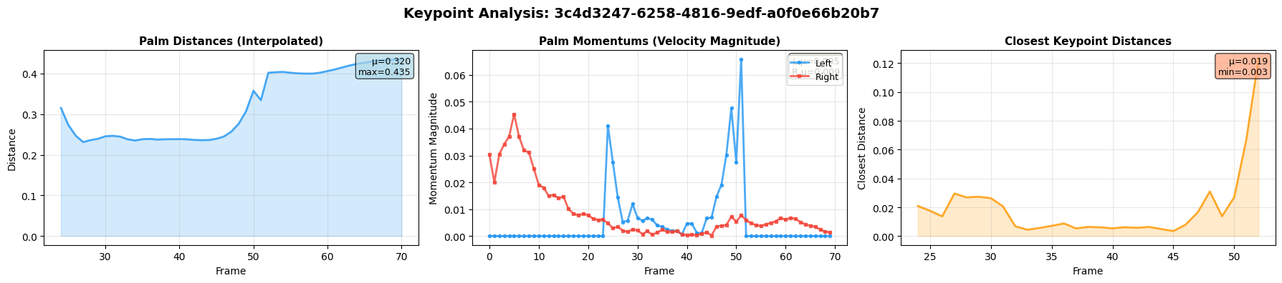

description:

Error 2: 8be52121-9cc3-479f-95c3-06baaf2c4dfa
Preparation frames: 1 (frames 0-0)
Stroke frames: 20 (frames 0-19)
Retraction frames: 67 (frames 20-86)
graphs:
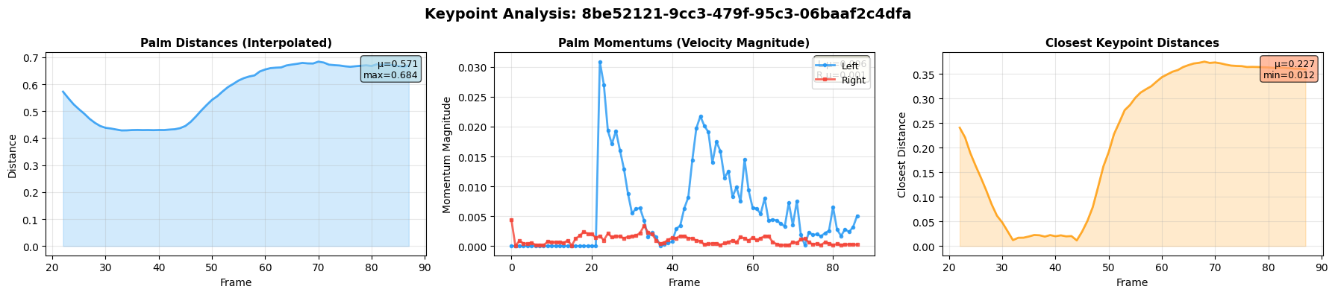

description:

Error 3: acf7a090-7ece-488a-a6e8-f4df878629a9
Preparation frames: 57 (frames 0-56)
Stroke frames: 26 (frames 57-82)
Retraction frames: 1 (frames 82-82)
graphs:
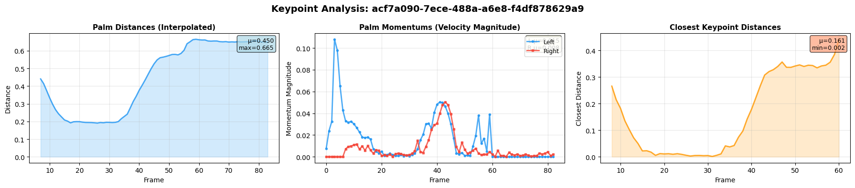

description:

Error 4: e7f57b3a-8262-4992-b0b2-f9cf68238935
Preparation frames: 33 (frames 0-32)
Stroke frames: 13 (frames 33-45)
Retraction frames: 5 (frames 46-50)

graphs:
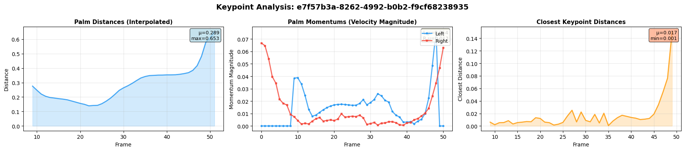

description:

